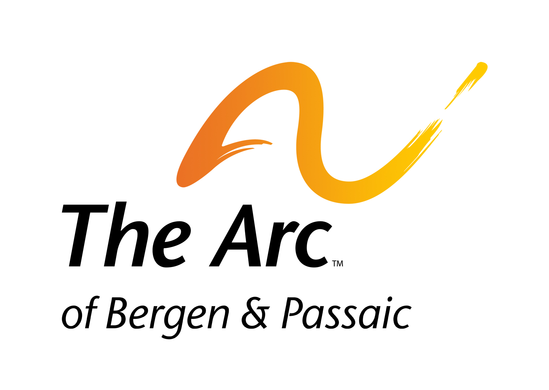
223 Moore Street
Hackensack, New Jersey 07601
T-201-343-0322
F- 201-343-0401
Email arc@arcbp.com
www.arcbergenpassaic.org

Achieve With Us

Holiday Dinner Dance Artisan Boutique
Vendor Contract

Tuesday December 11, 2018
6:00 pm – 10:00 pm
The Venetian
River Drive
Garfield, New Jersey 07026

Contact:
Marianne Balazs, Director of Development
201-343-0322 x 2225 dinner@arcbp.com

We are very happy that you have chosen to participate in the boutique at our Holiday Dinner. This event is a fundraiser for The Arc of Bergen and Passaic Counties, a not for profit organization for individuals with disabilities and their families.

Proceeds from this event will help us to continue providing critical services to over 1,300 individuals and their families throughout the year. Services such as early intervention for infants and toddlers, after school programs, summer camp, case management, respite, vocational training, job placement, adult day programs, residential homes and apartments and family support.

We do not require a percentage of your sales for the day but would be happy to accept any donation at the end of the night that you feel you would like to contribute. This is not a requirement. We want you to have a successful day as well!

Set Up Times: 4:00 pm – 5.30 pm

Vendor Fees: $60 per space (non-refundable) due by Friday December 7, 2018

Payment may be made by check or through our secure website portal to Pay Pal at www.arcbp.com or click the link PAY ON LINE HERE

The tables will be set up by the Venetian as one continuous beautifully draped boutique area. Each vendor will have approximately 6 ft. of space. Chairs will be provided at no extra cost.

*** Vendor will be responsible for collecting all required sales tax and for any fees including but not limited to NSF/bad check fees, return items, shipping etc.
Registration Form

Please provide all information below:

Name: ___________________________________________________________________

Address:__________________________________________________________________
Number & Street City State Zip

Business Name: ___________________________________________________________

Describe what you will be selling: (All items MUST be new and are subject to approval. REQUIRED: 2 photos of your merchandise emailed with this application to help in placement of vendors and to avoid multiple vendors with similar products. Products must be appropriate for a family event. Also, if available, a photo of your booth setup.) email to: dinner@arcbp.com
___________________________________________________________________________________________________________________________________________________________________________________________________________________________
_________________________________________________________________________

Phone: Business: ____________________ Cell Phone: __________________________

Email Address: ____________________________________________________________

A limited number of vendors can have access to electric if needed on a first come first serve basis. Please indicate below whether or not you are in need of an electric outlet.

Yes _________________________________ No________________________________

Please carefully review the Terms and Conditions on the following page as your signature accepting the terms and conditions is required to process your contract.

Terms and Conditions

- The Arc agrees to provide the Vendor named in this contract with space to conduct Vendor’s business at the Boutique at The Arc’s Holiday Dinner Dance to be held at the Venetian in Garfield on Tuesday December 11, 2018 from 6:00 pm – 10:00 pm in exchange for the fee set forth in this contract. Vendor accepts the opportunity to participate in the event and agrees to accept the Terms and Conditions listed herein.

- Vendor shall pay all fees (non-refundable) upon submission of this contract.

- Vendor may arrive no later than 4:30 pm not earlier than 4:00 pm to unload and setup their area. Vendor MUST dismantle Vendor’s booth no earlier than 9:30 pm and must be broken down by no later than 10:30 pm.

- Vendor is responsible for removing their own trash and cleaning their own booth space after the event leaving their space in the condition in which it was found.

- Vendor MUST without any exceptions use the table coverings provided by the Venetian.

- Vendors are responsible for providing their own props, displays, signage, etc.

- All displays, signage and items for sale must be displayed within Vendor’s booth space; nothing may block another Vendor’s booth. Each Vendor must maintain their booth space in an organized and neat manner. All displays must be appropriate for a family event.

- No electricity will be provided for Vendor’s booth unless requested on the contract and approved. Vendors using electricity must provide their own extension cords if needed.

- Vendor shall ensure the proper quality of products sold. The Arc reserves the right to reject or remove from the event any items considered unsuitable for a family event at our discretion. Such removal shall not result in a refund.

- Any vendor found to be creating a nuisance or conducting themselves in a manner unbefitting a family event shall be subject to eviction from the premises and will not be subject to refund.

- Vendor assumes full responsibility for their displays, booths, products, personal belongings and anything else they bring onto the premises. The Arc and the Venetian accept no liability for lost, stolen or damaged property.

- Vendor shall defend, indemnify and hold The Arc and the Venetian, along with its employees, board members, participants, volunteers or agents harmless from and against any and all claims and actions for personal injury, death, property damage, or other liability arising from or resulting from or in any way connected with the operation of the Vendor’s booth at the event or the products sold or given away by the vendor.

- Vendors will be able to unload at the back entrance of the Venetian.

- After unloading vendors must move their vehicle to the parking lot.

- The Arc makes no guarantee whatsoever with regard to how much, if any, money the vendor will make at the event.

I have read, understood and agree to the Terms and Conditions listed herein.

Vendor Signature ___________________________________ Date _____________

Print Name : _______________________________________

